Contents

1. Ask fields 2
1.4. Adding an ASK field 2
1.5. Syntax 3
1.6. 4
1.8. 4
2. IF field 7

Column1 heading | Column2 heading

Example:
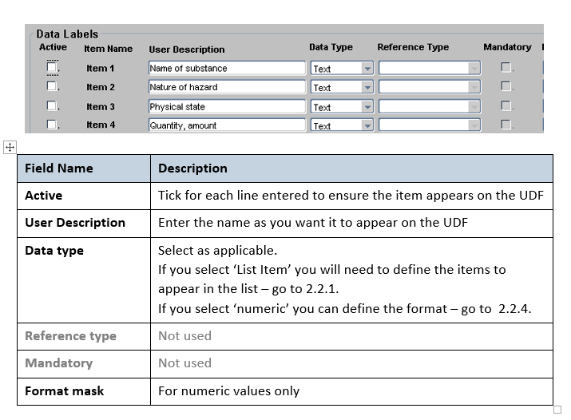

  - Navigation

Navigate to: enter > the > navigation > string > here

  - Prompts and reminders

 | NB: Things you must/must not do.

 | NB: Useful reminders and points to note/for info. The process won’t fail if you ignore this note.

  - Picking out key areas on images

Useful on busy screens or if item is not easily identifiable. Best done in Snag-it where possible as it is more flexible and the formatting is embedded into the image rather than sitting over the top.

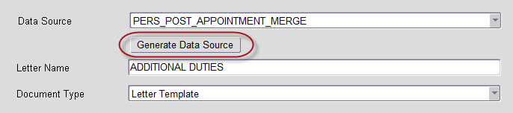

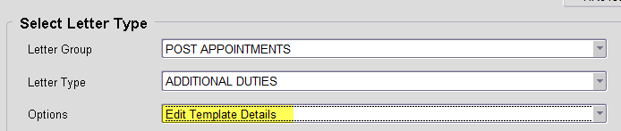

Knowledge Article: Add a link to the relevant knowledge article here

Ask fields

The Ask field code prompts you to enter information and assigns your response to a bookmark. For the information to appear in the document, you must insert a Ref field that refers to the bookmark. Word prompts you for a response each time you update the Ask field, such as when you press F9 or step through the records in a mail merge.

You can use the Ask field in a document or as part of a mail merge.

To display the response in the content of the document, you must insert a Ref field after the Ask field.

Adding an ASK field

- On the Insert tab, in the Text group, click Quick Parts, and then click Field.

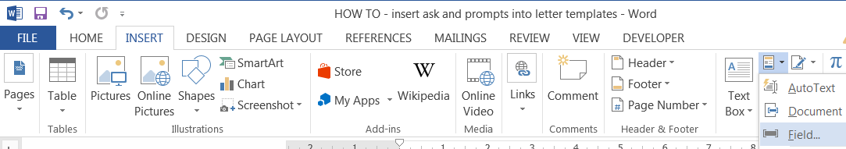

- In the Field names list, select Ask.

- In the Prompt box, type the question that you want answered.

- In the Bookmark name box, type a name for the bookmark that will store the response to the prompt.

- If you want a predefined response, select the Default response to prompt check box, and type the text.

- If you want the same response to apply to all the records in a mail merge, select the Prompt before merging bookmark text check box. Otherwise, Word will prompt you for a response with each record.

- Click OK

Example

To use the Ask field as part of a mail merge, do the following while you are setting up the mail merge:

- On the Mailings tab, in the Write & Insert Fields group, click Rules, and then click Ask.

- In the Bookmark box, type a name for the bookmark that will store the response to the prompt.

- In the Prompt box, type the question you want answered.

- If you want a predefined response, type the response in the Default bookmark text box.

- If you want the same response to apply to all the records in the merge, select the Ask once check box. Otherwise, Word will prompt you for a response with each record.

Syntax
When you view the Ask field code in your document, the syntax looks like this:
{ ASK Bookmark"Prompt" [Optional switches ] }

Note: A field code tells the field what to show. Field results are what is shown in the document after having evaluated the field code. To toggle between viewing the field code and the field code results, press Alt+F9.

Instructions

Bookmark
The bookmark name assigned to the response to the prompt, for example, ClientName.
"Prompt"
Prompt text, which is displayed in a dialog box — for example, "Enter the client's name."

Optional switches
\d "Default "
Specifies a default response if you don't type a response in the prompt dialog box. For example, the field
{ ASK Typist "Enter typist's initials:" \d "tds" } assigns "tds" to the bookmark Typist if you don't enter a response.
If you don't specify a default response, Word uses the last response that was entered. To specify a blank entry as the default, type empty quotation marks after the switch. For example, type \d "" .
\o

When used in a mail merge main document, displays the prompt one time instead of each time you merge a new data record. The same response is inserted in each resulting merged document.

  - Example
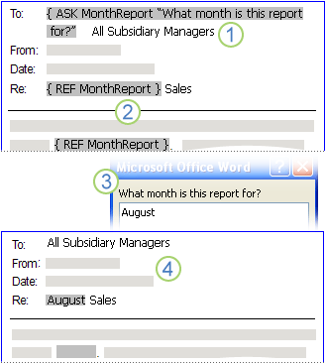

An Ask field with a bookmark of MonthReport and prompt of What month is this report for? has been inserted near the beginning of the document.

The month name occurs several places in the document. A Ref field that specifies the MonthReport bookmark has been inserted in each of these places.

If you perform a mail merge or press F9 while the Ask field is selected, Word displays the prompt. In this example, the user typed August in response to the prompt.

Each of the REF fields is updated with the content of the MonthReport bookmark: in this example, August.

Fill-In field
The Fill-In field prompts you to enter text. Your response is printed in place of the field.

Note: To insert your response in more than one location, use an Ask field.

Word prompts you for a response each time you update the Fill-In field, such as when you press F9 or step through the records in a mail merge. When you create a new document that is based on a template (a .dotm or .dotx file) and that contains Fill-In fields, Word prompts you for a response at each Fill-In field.

You can use the Fill-In field in a document or as part of a mail merge.

To use the Fill-In field in a document

On the Insert tab, in the Text group, click Quick Parts, and then click Field.



In the Field names list, select Fill-in.

In the Prompt box, type the question you want answered.

If you want a predefined response, select the Default response to prompt check box, and type the text.

If you want the same response to apply to all the records in a mail merge, select the Prompt before merging bookmark text check box. Otherwise, Word will prompt you for a response with each record.

Click OK.

To use the Fill-In field as part of a mail merge

While you are setting up the mail merge, do the following:

On the Mailings tab, in the Write & Insert Fields group, click Rules, and then click Fill-in.

In the Prompt box, type the question you want answered.

If you want a predefined response, type the response in the Default fill-in text box.

If you want the same response to apply to all the records in the merge, select the Ask once check box. Otherwise, Word will prompt you for a response with each record.

Syntax
When you view the Fill-In field code in your document, the syntax looks like this:
{ FILLIN ["Prompt "] [Optional switches ] }

Note: A field code tells the field what to show. Field results are what is shown in the document after having evaluated the field code. To toggle between viewing the field code and the field code results, press Alt+F9.

Instructions
"Prompt"
Text that is displayed in the dialog box — for example, "Enter the client's name:"
Optional switches
\d "Default"

Specifies a default response if you type nothing in the prompt dialog box. The field { FILLIN "Enter typist's initials:" \d "tds" } inserts "tds" if no response is entered.

If you don't specify a default response, Word uses the last response that was entered. To specify a blank entry as the default, type empty quotation marks after the switch. For example, type \d "".
\o

Prompts just one time during a mail merge instead of each time a new data record is merged. The same response is inserted in each resulting merged document.

Example
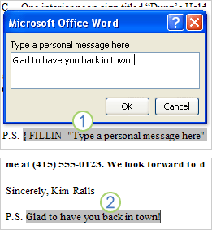

1. The document includes a postscript that consists of a Fill-In field. The prompt for the Fill-In field is Type a personal message here.

2. The Fill-In field is updated with the text that the user typed in response to the prompt.

IF field

The If field compares two values and then inserts the text appropriate to the result of the comparison. When used in a mail merge main document, the If field can examine information in the merged data records, such as postal codes or account numbers. For example, you can send letters to only those clients located in a particular city.

You can use the If field in a document, or you can use the If field as part of an If-Then-Else rule in a mail merge.

To use the If field in a document, do the following:

  - On the Insert tab, in the Text group, click Quick Parts, and then click Field.

  - In the Field names list, select If.

  - In the Field codes box, type the expressions, operator, true text, and false text, following the syntax shown above.

  - Click OK.

To use the If field as part of a mail merge, do the following while you are setting up the mail merge:

1.On the Mailings tab, in the Write & Insert Fields group, click Rules, and then click If...Then...Else.

2.In the Field name list, select the name of a merge field, such as City.

3.In the Comparison list, select the operator that you want. For example, to single out recipients in a particular city, select Equal to.

4.In the Compare to box, type the value that you want to use. For example, to single out recipients in Tokyo, type Tokyo.

Note: If you selected is blank or is not blank in the Comparison list, leave the Compare to box empty.

5.In the Insert this text box, type the text that you want to appear in the document when the condition that you specified is true. For example, to customize the text for recipients in Tokyo, you can type especially for your Tokyo neighborhood.

6.In the Otherwise insert this text box, type the text that you want to appear in the document when the condition that you specified is not true. For example, to provide generic text for recipients who are not in Tokyo, you can type especially for your surrounding neighborhood.

  - Syntax

When you view the If field code in your document, the syntax looks like this:

{ IF Expression1OperatorExpression2TrueTextFalseText}

Note: A field code tells the field what to show. Field results are what is shown in the document after having evaluated the field code. To toggle between viewing the field code and the field code results, press Alt+F9.

  - Instructions

Expression1, Expression2

Values that you want to compare. These expressions can be merge field data, bookmark names, strings of characters, numbers, nested fields that return a value, or mathematical formulas. If an expression contains spaces, enclose the expression in quotation marks.

Notes:

Expression2 must be enclosed in quotation marks so that it is compared as a character string.

If the operator is = or <>, Expression2 can contain a question mark (?) to represent any single character or an asterisk (*) to represent any string of characters.

If you use an asterisk in Expression2, the portion of Expression1 that corresponds to the asterisk and any remaining characters in Expression2 cannot exceed 128 characters.

Operator

Comparison operator. Insert a space before and after the operator.

Operator | Description
= | Equal to
<> | Not equal to
> | Greater than
< | Less than
>= | Greater than or equal to
<= | Less than or equal to

TrueText, FalseText

Text that results when the comparison is true (TrueText) or false (FalseText). If FalseText isn't specified and the comparison is false, the IF field has no result. Each string containing multiple words must be enclosed in quotation marks.

Example

The following example specifies that if the customer order is greater than or equal to 100 units, the text "Thanks" appears in the document. If the customer order is fewer than 100 units, the text "The minimum order is 100 units" appears in the document.

{IF order>=100 "Thanks" "The minimum order is 100 units"}

